ST10479540
ERD

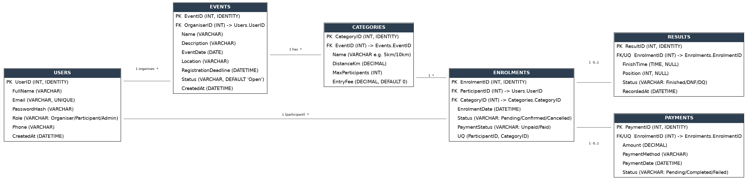

Relationships (and explanation for each)

User to Event — 1 organizes *
One organizer can create many events, one event can be created only by one organizer – it’s typical one-to-many. Relationship is established through OrganizerId foreign key in Events.

Event to Category — 1 has *
One event can belong to many categories (like 5km, 10km, half-marathon in the same event). Again, it’s one-to-many relationship, established through EventId foreign key in Categories.

User to Enrollments and Category to Enrollments – this is many-to-many
Participant can enroll to many categories, while one category can be enrolled to by many participants. So neither one side can refer to the other and we need junction/bridge table – Enrollments, which stores ParticipantId and CategoryId as foreign keys. It’s a typical approach to represent many-to-many relation in relational databases, because one can’t add many foreign keys from one table into another.
Enrolments → Results — 1 0..1
There can be no more than one result per enrolment since one cannot register and already have a result for a particular race (a result does not always exist, since the race has not been completed). There cannot be more than one result since one is only issued once during the completion of the race and never twice for the same entry.

Enrolments → Payments — 1 0..1
The same is true of payments: one per enrolment and the payment may not exist if there has not been any yet.

Why Results and Payments are connected to Enrolments, not Users/Categories

It is at this point where things get complicated. The result of participation in a race is "Sipho's result" only in connection with a specific race, not just by itself. If Sipho participates in two races, he will need two entries of his results – one per enrolment and not per user (the same is true of payments).

COMRADES MARATHON ENDPOINT
Authentication
HTTP Method | Route | Description | Role Required | Request Body | Expected Response
POST | /api/auth/login | Authenticate user and return JWT token. | None (Public) | { "email": "string", "password": "string" } | HTTP CODE :  200 OK - Token + user info
POST | /api/auth/signin | User Signs in if they don’t have an account, using their name, email and password. | None (Public) | { "firstName": "string", "email": "string", "password": "string", "confirmPassword": "string" } | HTTP CODE :  201 Created - User object with token

User Accounts

GET | /api/users/email | Get current authenticated user's profile. | Any (Logged in) | None | HTTP CODE :  200 OK - User profile object
PUT | /api/users/profile | It will update current user's profile. | Any (Logged in) | { "firstName": "string", "email": "string", "password": "string" } | HTTP CODE :  200 OK - Updated user object
GET | /api/users/{id} | It will get the users public profile. | Any (Logged in) | None | HTTP CODE :  200 OK - User public profile
GET | /api/users | It will list all users on the admins side. | Admin | None | HTTP CODE :  200 OK - Array of users

Events
GET | /api/events | Events will be listed with an option to filter(date, location, etc) | None (Public) | None | HTTP CODE :  200 OK - Array of events with pagination
GET | /api/events/{id} | It will get specific details on the event. | None (Public) | None | HTTP CODE :  200 OK - Event details with categories
POST | /api/events | Creates a new event. | Organiser | { "title": "string", "description": "string", "date": "ISO date", "location": "string", "status": "string" } | HTTP CODE :  201 Created - New event object
PUT | /api/events/{id} | Updates an existing event. | Organiser (owner only) | { "title": "string", "description": "string", "date": "ISO date", "location": "string", "status": "string" } | HTTP CODE :  200 OK - Updated event
DELETE | /api/events/{id} | Deletes an event. | Organiser (owner only) | None | HTTP CODE :  204 No Content - Deleted

Categories
GET | /api/events/{eventId}/categories | It will get all the categories for an event. | None (Public) | None | HTTP CODE :  200 OK - Array of categories  404 Not Found - Event not found
POST | /api/events/{eventId}/categories | It will add a new category for a specific event. | Organiser | { "firstName": "string", "description": "string", "distance": "number", "ageGroup": "string", "price": "number" } | HTTP CODE :  201 Created - New category
PUT | /api/categories/{id} | Updates a category. | Organiser | { "name": "string", "description": "string", "distance": "number", "ageGroup": "string", "price": "number" } | HTTP CODE :  200 OK - Updated category
DELETE | /api/categories/{id} | Deletes a category. | Organiser | None | HTTP CODE :  204 No Content - Deleted

Enrolment
GET | /api/events/{eventId}/enrolments | It will get all the enrolments of the event. | Organiser | None | HTTP CODE :  200 OK - Array of enrolments
POST | /api/events/{eventId}/enrol | Enrols a participant in an event | Any (Logged in) | { "categoryId": "number" } | HTTP CODE :  201 Created - Enrolment details  400 Bad Request - Already enrolled  404 Not Found - Event/category not found
GET | /api/users/enrolments | Gets current user's enrolments. | Any (Logged in) | None | HTTP CODE :  200 OK - Array of user's enrolments
PUT | /api/enrolments/{id} | Updates enrolment status. | Participant or Organiser | { "status": "string" } | HTTP CODE :  200 OK - Updated enrolment  403 Forbidden - Not owner  404 Not Found - Enrolment not found
DELETE | /api/enrolments/{id} | Cancels enrolment | Participant or Organiser | None | HTTP CODE :  204 No Content - Cancelled  403 Forbidden - Not owner  404 Not Found - Enrolment not found

Results
GET | /api/events/{eventId}/results | It gets all results for an event. | None (Public) | None | HTTP CODE :  200 OK - Array of results with participant names
GET | /api/enrolments/{id}/result | It gets results for a specific enrolment. | Participant or Organiser | None | HTTP CODE :  200 OK - Result object  404 Not Found - Result not found
POST | /api/enrolments/{id}/result | Add/record result for an enrolment. | Organiser | { "finishTime": "ISO duration", "position": "number", "status": "string" } | HTTP CODE :  201 Created - New result  404 Not Found - Enrolment not found
PUT | /api/results/{id} | Update an existing result. | Organiser | { "finishTime": "ISO duration", "position": "number", "status": "string" } | HTTP CODE :  200 OK - Updated result  403 Forbidden - Not organiser  404 Not Found - Result not found
DELETE | /api/results/{id} | Deletes a result. | Organiser | None | HTTP CODE :  204 No Content - Deleted  403 Forbidden - Not organiser  404 Not Found - Result not found

Dashboard
GET | /api/dashboard/organiser | Gets organiser's event statistics. | Organiser | None | HTTP CODE :  200 OK - Stats (total events, participants, results)
GET | /api/dashboard/participant | Gets participant's race statistics. | Any (Logged in) | None | HTTP CODE :  200 OK - Stats (events completed, best time, etc.)

Creating database
